Dorico: Notes about Note Input
- Mouse
Select the corresponding note values ​​with the mouse on the left and insert them into the bar by simply clicking at the desired position along the bar grid. The rest values ​​are automatically set. Incorrect entries can be corrected by overwriting them. Notes can be deleted using the Backspace/Delete key.

- On-screen piano keyboard (iPad)
On desktop show and hide the lower zone with the arrow button at the bottom of the screen or shortcut Ctrl/Cmd-8

- QWERTY keyboard (duration before pitch)
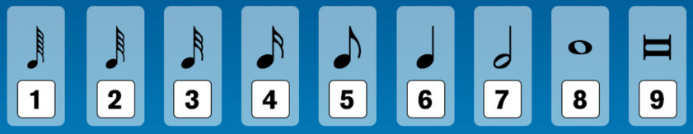
- A-G for pitches

- QWERTY keyboard (pitch before duration)
- K for pitch before duration

- MIDI keyboard
- Ctrl-R (Windows), Cmd-R for Record
- Spacebar for stop
- Library > Playback Options > Click for options and count-in

- Transpose pitches (alt: octaves, diatonic, chromatic)
- Alt-Up and Down (Windows), Opt-Up and Down (Mac) for diatonic
- Shift-Alt-Up and Down (Windows), Shift-Opt-Up and Down (Mac) for chromatic
- Ctrl-Alt-Up and Down (Windows), Cmd-Opt-Up and Down (Mac) for octaves

- Accidentals
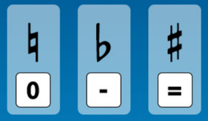
NOTE: the Preferences whether accidentals, dots, and articulations are selected BEFORE or AFTER note input will make a difference
- Use Alt with the above for changing enharmonically changing a selected note

- Rhythm dots
- Double-tap a number (duration before pitch only)
- . / period / full stop

- Triplets
- ; for tuplet popover
- : (Shift ;) to stop the tuplet

- Mixed length triplets

- Tuplets (starting and stopping different tuplets)
- Use ratios, e.g. 4:3 or 5:4q
w = whole note
h = half note
q = quarter note
e = eighth note
x = 16th note
y = 32nd note
z = 64th note

- Rests and rhythmic grid
- Arrow keys left and right = move along rhythm grid
- Space bar = move along rhythm grid by selected beat duration
- Alt [ and Alt ] to change rhythm grid

- Grace notes
- / (slash) to toggle grace note on/off
- Alt / to toggle slash/unslashed grace notes

- Chord input (qwerty)
- Q = Chord mode

- Manual (changing) beaming
- Right-click for beaming options

- Polyphonic notation (voices/layers)
- Shift V to create a new voice
- V to toggle available voices
- View > Note and Rest Colors > Voice Colors

- Copy and Move
- R to repeat the selection
- Alt-click to copy and paste
- Ctrl-C (Windows), Cmd-C (Mac) to copy
- Ctrl-V (Windows), Cmd-V (Mac) to paste
- Alt-N for move to staff above
- Alt-M for move to staff below

- Lengthen and shorten (note values and other items)
- Shift-Alt-right / left arrow to lengthen and shorten (Shift-Opt on Mac)

- Half and double note lengths
- Ctrl-Shift-Alt right / left arrow to double and halve (Cmd-Shift-Alt on Mac)

- Insert mode
- i to toggle on / off

- Cutting ties and note values
- T to tie
- U to cut/snip

- Force duration
- O (letter o) to toggle on / off

- Lock duration
- L to toggle on / off

- Slurs and flipping items
- S to turn on/add a slur (Shift-S to turn off)
- F to flip beams/slurs/items

- Articulation
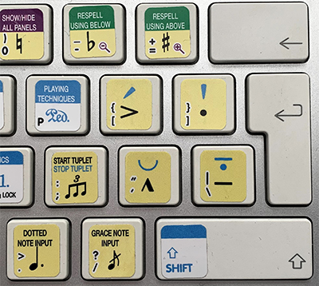
- UK International keyboard layout
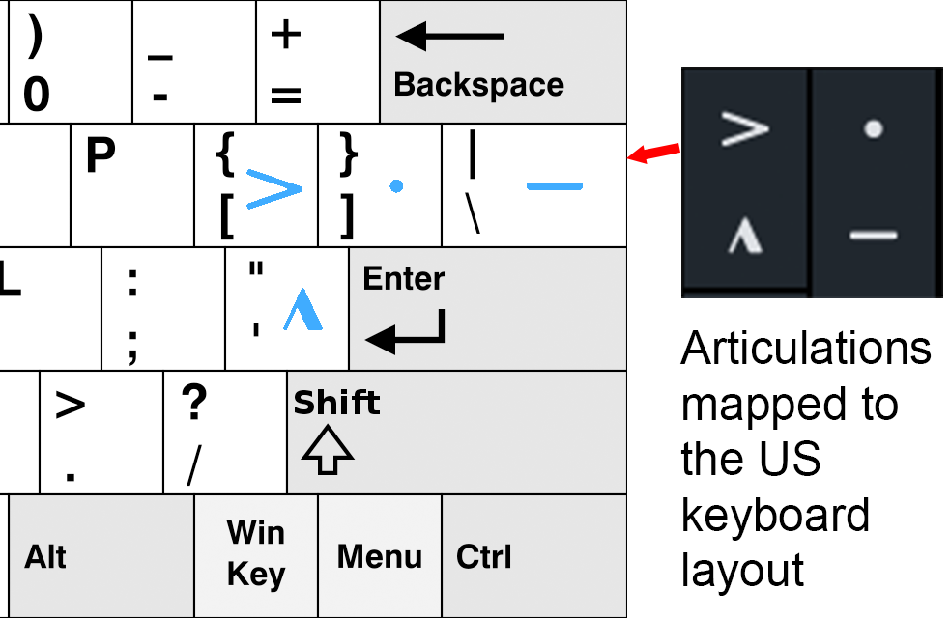
- US keyboard layout

- Rhythm notation and slashes
- Shift-Alt-V to make a new slash voice
- V to toggle available voices
- Shift-R then type slash

- Bar repeats
- Shift-R then % or %2 or %4

